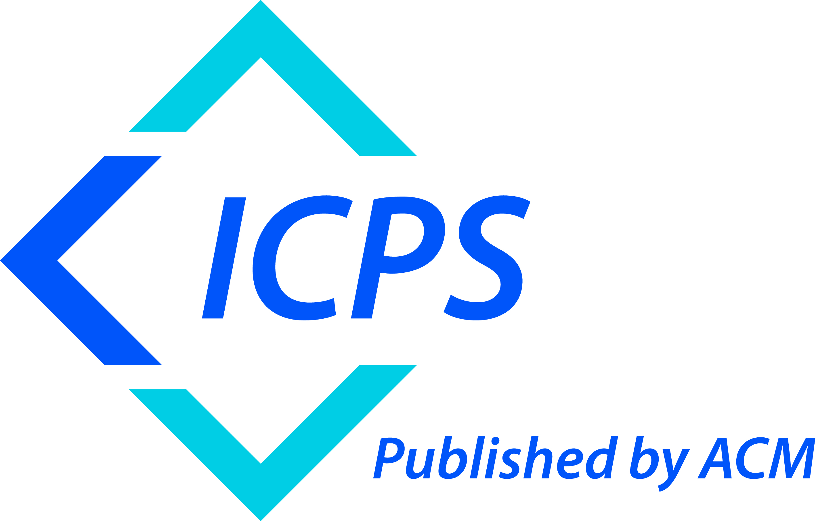

The Association for Computing Machinery
1601 Broadway, 10th Floor
New York, New York 10019, USA

ACM COPYRIGHT NOTICE. Copyright © 2022 by the Association for Computing Machinery, Inc. Permission to make digital or hard copies of part or all of this work for
personal or classroom use is granted without fee provided that copies are not made or
distributed for profit or commercial advantage and that copies bear this notice and the
full citation on the first page. Copyrights for components of this work owned by others
than ACM must be honored. Abstracting with credit is permitted. To copy otherwise, to
republish, to post on servers, or to redistribute to lists, requires prior specific permission
and/or a fee. Request permissions from Publications Dept., ACM, Inc., fax +1 (212) 869-0481,
or permissions@acm.org.

For other copying of articles that carry a code at the bottom of the first or last page,
copying is permitted provided that the per-copy fee indicated in the code is paid
through the Copyright Clearance Center, 222 Rosewood Drive, Danvers, MA 01923,
+1-978-750-8400, +1-978-750-4470 (fax).

ACM ISBN: 1-59593-XXX-X

